Practical R Activity Seven

Random Forest Analysis

Michael Surdek
Southern New Hampshire University
DAT 640: Predictive Analytics
Professor Tom Woolman
February 20, 2022
For this activity I chose the Ecdat HDMA data set, which contains 13 attributes of mortgage loan applications including credit score, marital status, race, and whether the mortgage was ultimately approved or denied. There are 2381 observations in the dataset. Only 285, or about 12% of the applications, were denied and the other 88% were approved. A decision tree algortihm can determine the variables have the largest impact on the outcome of the application and can be used to predict whether a future application will be approved or denied. Additionally, a random forest algorithm can efficiently generate hundreds of randomly sampled decision trees and can use a wisdom of the crowd approach for more accurate predictions.
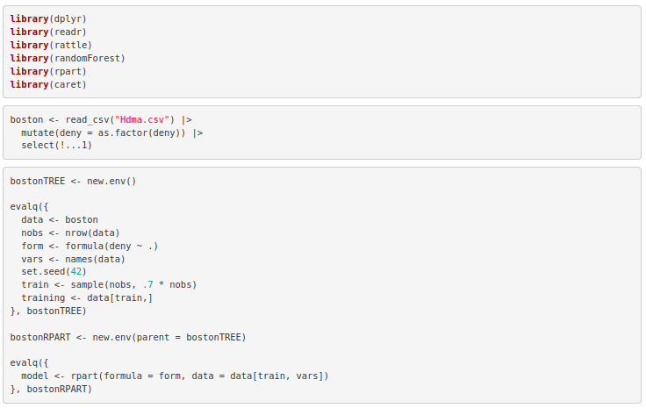
The code above loads the packages that I used as well as the HDMA data set, then builds the decision tree using the rpart function on the training data. The decision tree can easily be viewed by printing or even drawing the rules.

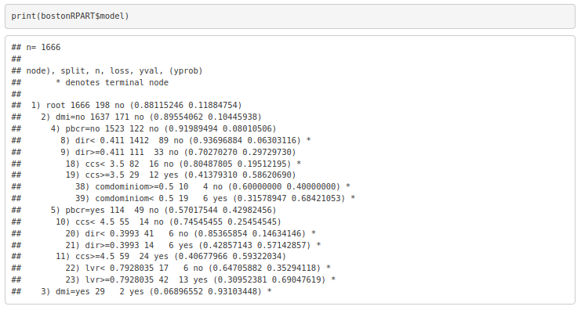
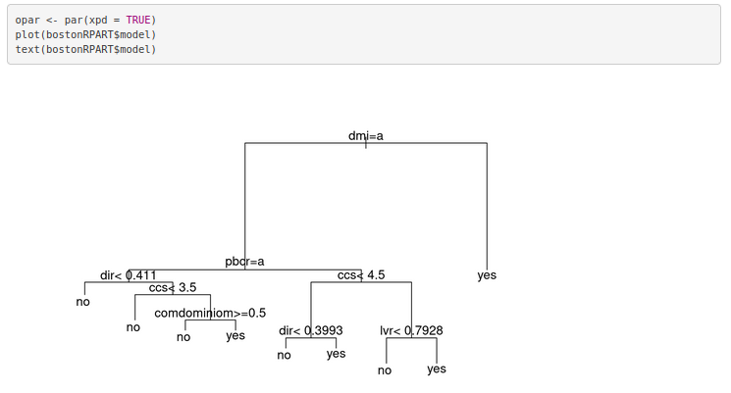
The first node of the decision tree evaluates dmi, which is whether the applicant was denied mortage insurance. If dmi = yes, then the prediction is yes that the mortage application will be denied. This makes sense, of course, a mortage will not be approved unless the applicant was pre-approved for mortage insurance. If dmi = no, the next node evaluates pbcr, which stands for ‘public bad credit record’. This node will not result in a prediction. Instead, it would procede to the dir node if pbcr = no and to the ccs node if pbcr = yes, and continue this process until a terminal node is reached. A confusion matrix is the best way to analyze the results of the model and the accuracy of its predictions.
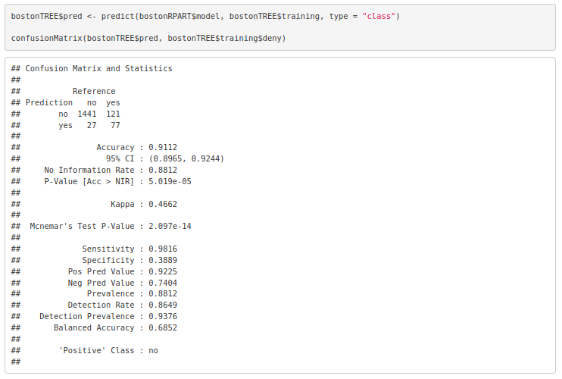
The confusion matrix groups the objects according to their observed value from the original data and their predicted value from the decision tree. There were 1468 applications that were approved, and 1441 of those, or 98.2 percent, were correctly predicted. On the other hand, of the 198 applications that were denied, only 77 were predicted as such. In these cases, the decision tree was only successful about 39% of the time. The overall accuracy of the model according to the output above is 91%. The confusion matrix also provides other information to help evaluate the model such as a confidence interval and p-value.
A random forest algorithm can be implemented in a very similar way as the decision tree, only using the randomForest function and setting some additional parameters such as the number of trees to build and the number of variables to randomly sample at each node.
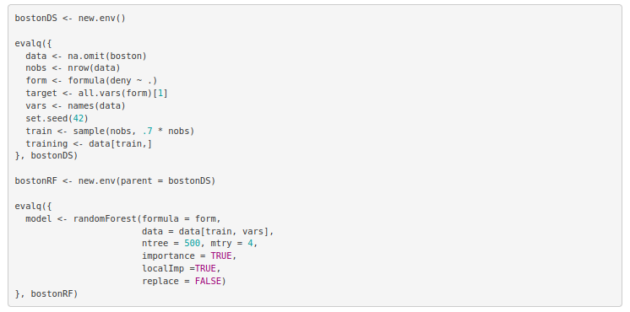
Some key information from the random forest model is variable importance. This includes the importance of each variable on the yes/no output as well as the mean decrease in the accuracy and the Gini index of the model. MeanDecreaseAccuracy is “based on a process of randomly permuting the values of a variable across the observations and measuring the impact on the predictive accuracy of the resulting tree.” (Williams, 2011) A higher value means the attribute is more important than the others, because the actual values provide significantly more accuracy than if they were generated randomly. MeanDecreaseGini is based on the “node’s impurity (the splitting criterion) when splitting on a variable.” (Williams, 2011) This metric has to do with the discretized nature of a decision tree, and how the model would change if different values were set for the splitting criterion.
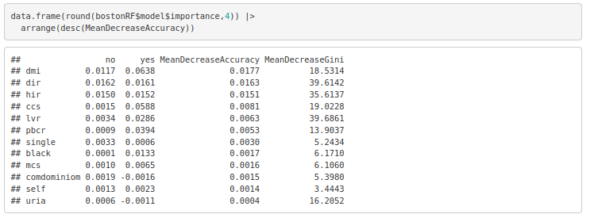
The most important variables according to MeanDecreaseAccuracy are dmi, dir, and hir. You can also see that dmi has a larger impact on whether there is a yes prediction than a no prediction, whereas most of the other variables have a similar impact on yes and no. This aligns with the original decision tree where a yes for dmi (denied mortgage insurance) led to an automatic prediction of yes for a denied mortgage application. These importances can also be compared to those of the original decision tree. Pbcr is more important in the decision tree than the random forest. In the decision tree, it was the second node after the initial dmi evaluation. Lvr, the ratio of the loan size to the property value, is more imporant in the random forest, especially according to MeanDecreaseGini.
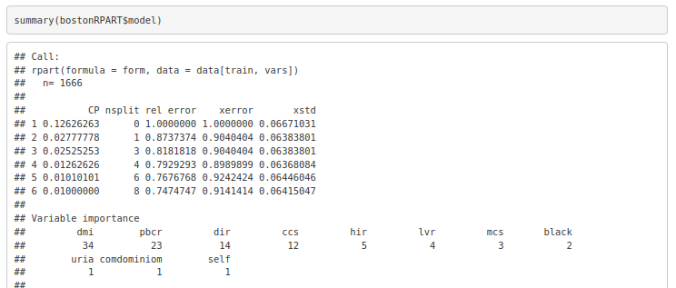
The random forest model can also be evaluated by its out-of-box error rate. This is the percent of incorrect predictions that are applied to the portion of the training data that is exlcuded from the building of each decision tree.
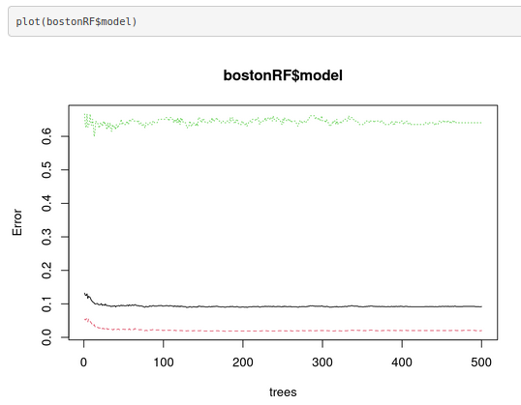
The black line is the OOB error rate. After only about 30 trees, it levels out around 9.3%. The green line, which is the error rate on yes observations, levels out around 64%. The red line is for no observations and reaches about 2%. These are each very similar to the accuracy values of the original decision tree, although this is expected with the out-of-box predictions. The random forest model is significantly more accurate when comparing the confusion matrices. The random forest correctly predicted 1474/1474 no observations and 191/192 yes observations, for a total accuracy of 99.94%. This is a massive improvement over the 91.12% accuracy of the original decision tree. The confidence interval and p-value from the confusion matrix output also point to the additional predictive value of the random forest algorithm.
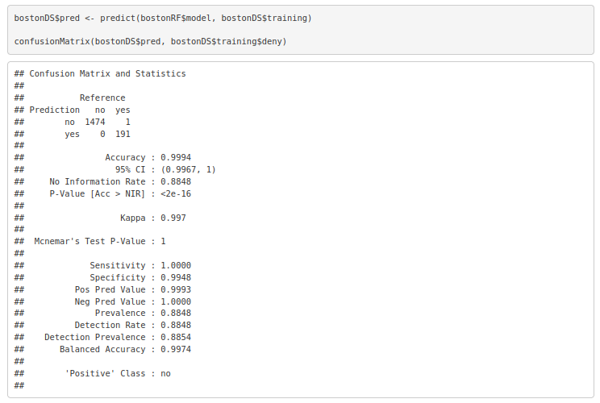
References:

Williams, Graham. 2011. Data Mining with Rattle and R : The Art of Excavating Data for Knowledge Discovery. Springer New York. Retrieved from http://ebookcentral.proquest.com/lib/snhu- ebooks/detail.action?docID=770229

